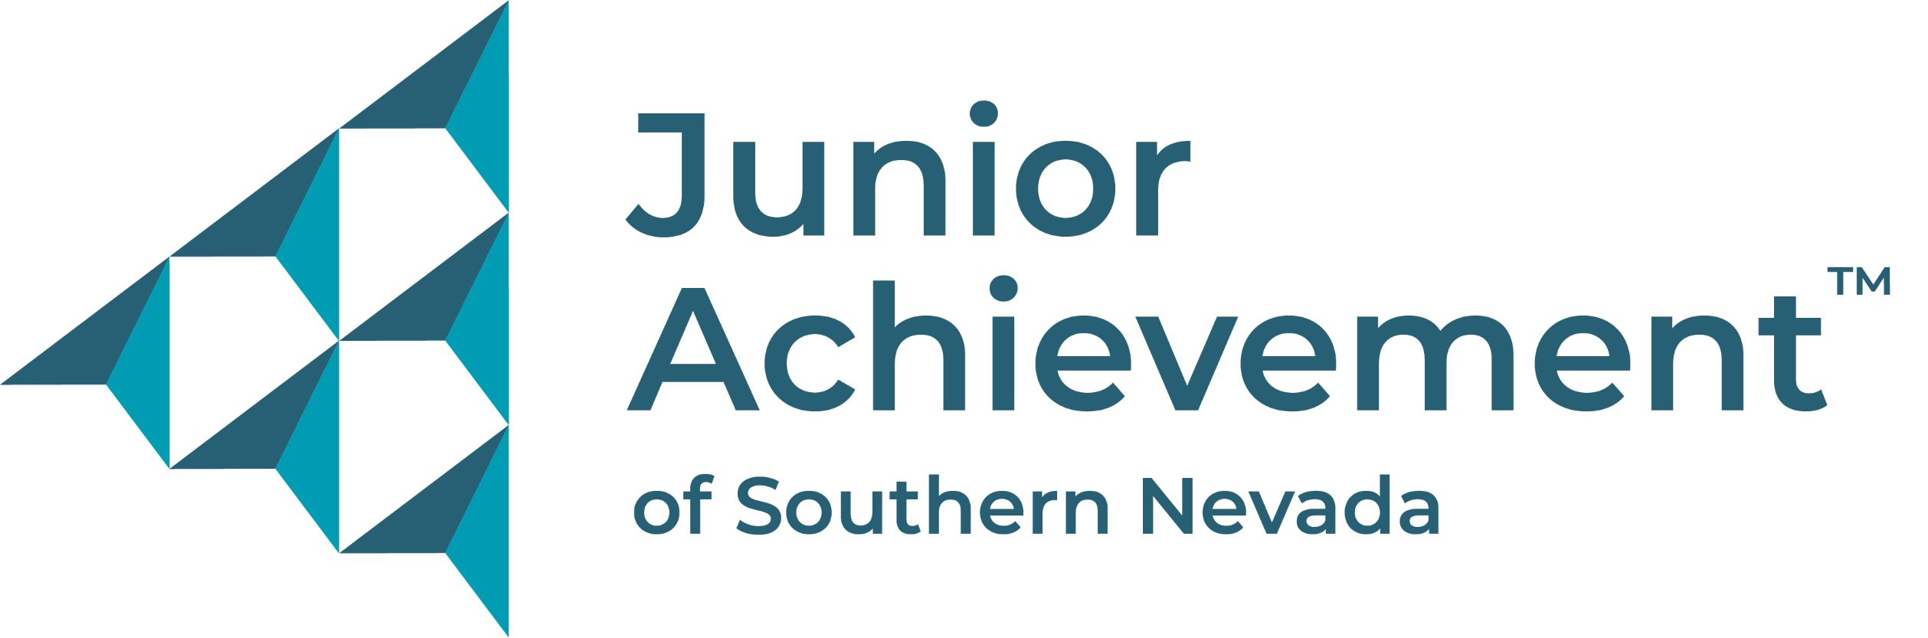
March X, 2023
FOR IMMEDIATE RELEASE:
Photo links are below.

Businesses Can Help Students “Swim With The Big Fish”
Sponsorships available for May 2 Junior Achievement
Shark Tank-Style Competition and Luncheon

A Shark Tank-style competition provides a great opportunity for entrepreneurs, companies and professionals to support local youth. Swimming With The Big Fish is an annual event featuring local fifth graders presenting new business startup concepts and plans to win scholarship money following in-classroom instruction and mentorship by volunteers from the business community.

A program of Junior Achievement of Southern Nevada, Swimming With The Big Fish will be presented by PNC Bank Tuesday, May 2, 11 a.m. to 1:30 p.m., and is hosted at Allegiant Stadium by the Las Vegas Raiders. More than 400 business and community professionals are expected to attend the luncheon. The young entrepreneurs – fifth graders from Fay Herron Elementary School – will make their presentations to a panel of local judges, with the audience also voting for their picks via smartphone.

Various event sponsorship opportunities are still available from $500 for a table of 10 to $7,500, which includes recognition in event program, logo inclusion in various mediums, inclusion in media materials and two reserved tables for 20 guests. There are also $1,500, $2,500 and $5,000 options, each with increasing benefits covering awareness, signage and messaging opportunities. To participate or for more information, email will.abbott@ja.org or call 714-878-8251.

The keynote speaker is Jan Jones Blackhurst, executive vice president – government relations and corporate responsibility at Caesars Entertainment Corporation. Information will also be shared about ways to get involved with Junior Achievement to invest in youth to better prepare them for the business of life.

Swimming With The Big Fish was created as a meaningful and entertaining way to engage the business community, which is vital to the success of Junior Achievement’s financial literacy programs through volunteerism, partnership and sponsorship. The nonprofit organization works with schools to provide K-12 students with needed curriculum covering financial education, entrepreneurship and workforce development that schools don’t have the resources to offer themselves and many students do not learn at home. These lessons help many students become financially secure adults, breaking the cycle of generational and situational poverty.

The event incorporates the JA: It's My Business! entrepreneurship program, which provides students with the necessary tools to create a business from the ground up. Junior Achievement staff and volunteers work with students throughout the six-week process. Students are separated into teams based on interest in apps, food and beverage, clothing and accessories, technology, and animals. They subsequently develop their idea for a business beneficial to the community and create business and marketing plans as a team. Between three and five student teams are expected to present during the event.

Current Swimming With The Big Fish sponsors are the Gene Haas Foundation, Las Vegas Raiders and Allegiant Stadium, PNC Bank, Findlay Automotive Group, RSM, Penta Cares Foundation, City National Bank, Cragin & Pike, Fontainebleau Las Vegas, Lexus of Las Vegas and Southwest Airlines. The University of Nevada, Las Vegas is the Student Scholarship Sponsor, and its $15,000 donation will go to the top three winning teams.

Products students previously developed for the competition include: a pen that helps people with dyslexia (2022 winner), positive social media influencer resource (2021 winner), a basketball that helps athletes who can't afford expensive trainers, a brush that detects and treats unhealthy hair, undergarments both with an SOS signal for those in distress and for relief for menstrual cramps, and wellness and mental health apps.

About Junior Achievement of Southern Nevada
Junior Achievement of Southern Nevada, Inc. was founded locally in 1996. The organization is dedicated to providing financial education to K-12 students, with a curriculum that spans from budget management to economic principals, workforce skills and credit. Junior Achievement of Southern Nevada reaches more than 20,000 students annually in the Las Vegas area with the help of 285 businesses and 6,800 business role models. For more information visit https://jasnv.org/ and follow on Instagram and Facebook.

# # #
VISUAL ASSETS
Current 2023: https://www.dropbox.com/scl/fo/aniv5cwj675klqv1cstl6/h?dl=0&rlkey=y2nh8rqqcat93z4mkd18jc47h

2022 Photos: https://www.dropbox.com/scl/fo/whwm5typqiss8ci0m4rjq/h?dl=0&rlkey=d1q6hxqz42q86a5j162glqgo7

MEDIA CONTACT:
Nancy Katz, Purdue Marion & Associates, 702-349-0063 or nancy@purduemarion.com

